REMOTE OPERATED VEHICLE (ROV)

# ROBOTICS HARDWARE SYSTEMS

# MCTE 4362 (SECTION 1)

# ASSOCIATE PROFESSOR DR ZULKIFLI ZAINAL ABIDIN

## ASSIGNMENT 1

## MUHAMMAD HARITH FIRDAUS BIN HAIRUL NIZAM

## 1912805



INTERNATIONAL ISLAMIC UNIVERSITY MALAYSIA

**INTRODUCTION**

ROVs (Remotely Operated Vehicles) are underwater robots that enable us to study the ocean without physically entering it. ROVs, which are submersible vehicles, are operated by a pilot and connected to the vessel through a strong cable called the umbilical cable. This cable serves as the primary tethering mechanism, providing electrical power and facilitating the transfer of data between the vessel and the ROV. The ROV's movement is controlled by multiple thrusters, which enable it to move and manipulate in any direction at speeds of up to ± 2 knots. Typically, ROVs are limited to conducting small-scale observational investigations.

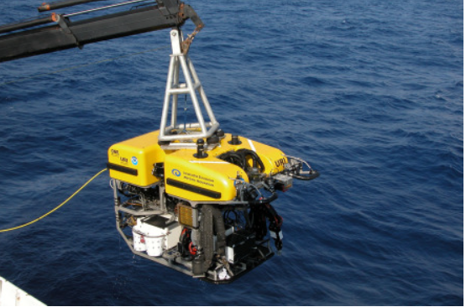

Figure . Typical Deepwater ROV system

Among ROVs that has been operated is the two-body ROVs, Deep Discoverer and Seirios, which have two separate bodies. Deep Discoverer is capable of functioning in both the water column and on the ocean floor, and Seirios is connected to it by a tether to stabilize it against the ship's motion. This setup enhances the lighting and camera abilities, which results in a wider range of the ocean view. However, managing and transporting a two-body system is more complex compared to a single-body ROV.

When installing an ROV, it is important to take into account various factors such as the location, deck structure, power supply, electrical safety, and operational safety. In situations where high-intensity work scopes are required, such as batch drilling, development, workover, or intervention operations, some vessels and operators choose to install two separate units.

**HISTORY & APPLICATIONS**

**History:**

1950

* used for oceanographic research
* Dimitri Rebikoff, a French inventor who developed the first ROV
* Explore shipwrecks and underwater caves

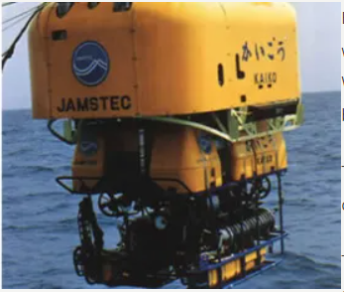

Figure . POODLE (first ever ROV)

1960

* US Navy began using ROVs for underwater mine clearance and for exploring deep-sea trenches.
* The development of Cable-Controlled Underwater Recovery Vehicle (CURV)
* CURV was used for a variety of tasks, including recovering sunken ships and planes, and exploring the ocean floor.

1970

* ROVS are used at greater depth
* Oceaneering Magna ROV used in the offshore oil industry in the Gulf of Mexico (1974)

**Applications:**

1. **Oil and Gas industry**
   1. Drilling, inspection, and maintenance
   2. Examining pipelines, subsea equipment and oil platforms
   3. Detect damages or leaks
2. **Underwater exploration**
   1. Investigate deep sea
   2. Record data on underwater environments
   3. Study marine life & geological features
3. **Search & Rescue missions**
   1. Recover objects, wreckage, bodies from water
4. **Military** 
   1. Mine detection & clearance
   2. Reconnaissance
   3. Surveillance operations
5. **Scientific research purposes** 
   1. Gathering samples
   2. Monitoring marine life
   3. Exploring the ocean environment

**MAIN COMPONENTS**

1. **Frame and Hull:** An ROV's frame is responsible for supporting and connecting all of its parts, while the hull ensures the ROV remains buoyant and safe from the water's pressure.

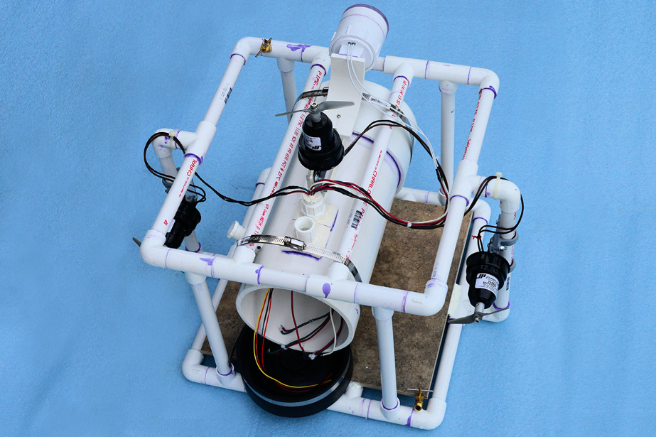

Figure . Typical ROV's frame (build with PVC pipe)

1. **Propulsion System:** The task of propelling the ROV through water falls to its propulsion system, which typically employs remote-controlled electric thrusters.

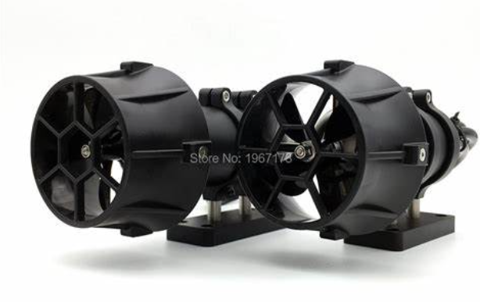

Figure . Remote-Controlled electric thrusters

1. **Power Supply:** The power supply furnishes electricity to various systems of the ROV, such as thrusters, cameras, lights, and sensors. The ROV can rely on rechargeable batteries, surface-connected power cables, or a hybrid approach to power supply.
2. **Control System:** The control system empowers a surface-based operator to manage the ROV's activities and movements using joysticks, cameras, and sensors that relay data to the operator.

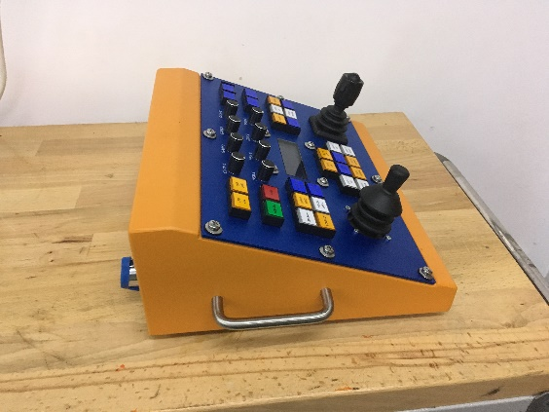

Figure . ROV's joystick from Delta ROV Inc

1. **Sensors and Cameras:** ROVs come equipped with various cameras and sensors that enable operators to observe and engage with their surroundings, such as sonar, video cameras, depth sensors, temperature sensors, and other specialized sensors.
2. **Manipulators:** Certain ROVs feature manipulators, which are robotic arms capable of either collecting samples or manipulating objects on the seafloor.

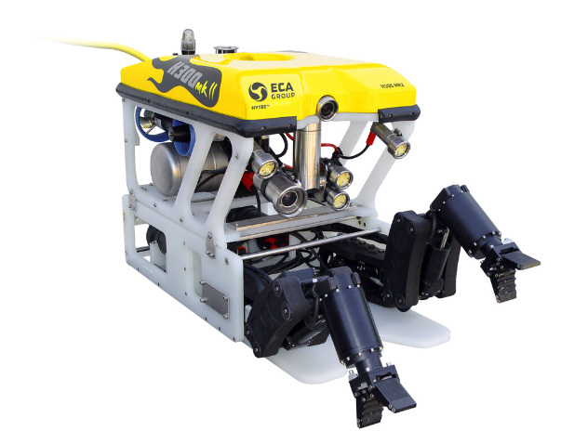

Figure . ROV's with robotics arm by ECA Group

1. **Payloads:** ROVs can transport a range of payloads, including scientific gear, sampling tools, and other specialized instruments.

Conclusively, ROVs were initially created in the 1950s and have since become indispensable in many sectors. ROVs are well-suited for underwater research, oil and gas exploration, and military applications because they can navigate to depths that would otherwise be impossible for humans to reach. The principal parts of an ROV are its frame, propulsion system, power supply, control system, cameras and sensors, and manipulators. ROVs have the capability to transport various payloads, such as scientific equipment, sampling tools, and specialized instruments.